Educational business tools for creatives and professionals.



In order to understand and learn the mechanics of the music business, it is crucial to have a basic knowledge of how to interact in a professional manner and furnish information required to conduct industry transactions.

DigiRAMP educates and provides simple, professional tools for its’ users to engage in professional business and build their career.

## MUSICRAFE (Lion) 3TB MacPro:private:var:folders:5l:cxc7l3t88xjdhq0059b276n00000gp:T:TemporaryItems:size_184x184_Peter_Rafelson_PRshot.jpg

# Letter from Founder

With thirty years in the music business, I have personally experienced the challenges and barriers of entry to this profession. I was fortunate to have enough success to build my own label and publishing company, but no way to manage all the work I created. With over Thirty-One #1 hits, and Five Thousand copyrights, there was no easy solution. I saw the need to build it. Harnessing new technology and the knowledge of how to run a successful business, I founded DigiRAMP with an extraordinary designer, Max Grønlund. This platform is now available for students to learn how to manage and administrate their own rights and content, promote and share their work and conduct real business. We are providing a comprehensive educational system to students who now will have the legal and industry-ready tools to excel in a new and exciting profession. *Build your music career with* DigiRAMP.

Peter Rafelson, Co Founder – DigiRAMP

# Testimonial from MI Faculty

Having worked in the music industry for over 35 years as an executive, entrepreneur and now teaching music business courses at MI, I find DigiRAMP to be a game changer.  The level of detail, scope and thoroughness it provides is second to none. It is a vital educational tool that offers a real world foundation and platform from which you can quickly set up your music company and start to conduct business with music industry professionals worldwide.

Ritch Esra, Instructor, Music Business Program – Musicians Institute

# On DigiRAMP, Students learn as they collaborate and engage directly in business.

## Inter-disciplinary application

DigiRAMP supports collaboration with multiple roles and student from different academic programs. Team Projects are shared in a fluid environment where students interact creatively and professionally:

## Writers/Composers • Artists/Musicians • Producers/Engineers • Business Majors

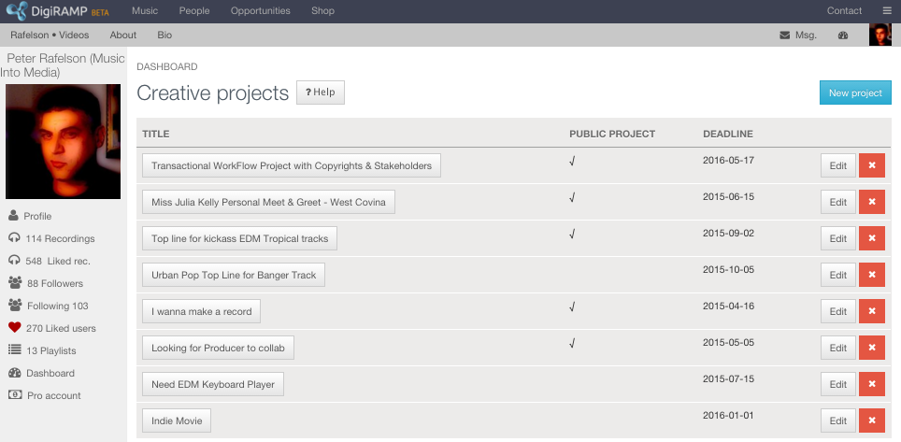

## Any student may post a Creative Project. Other users can then apply to fulfill a role:

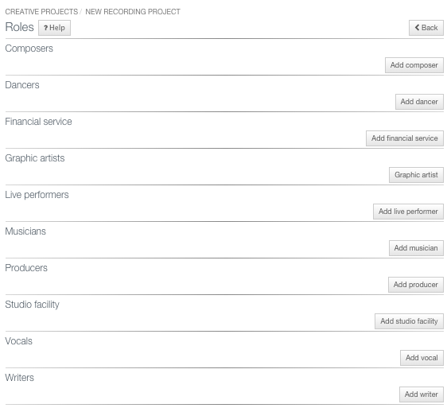

Digital files (i.e. lyrics, vocal tracks, performances, recordings, mixes) can then be uploaded and shared by the confirmed members of Project Team.

## Creative Project Roles

The ownership structures and business participation in each project are defined and agreed to directly in the online workflow, negating confusion and arguments, which commonly arise between creatives later in a collaborative process:

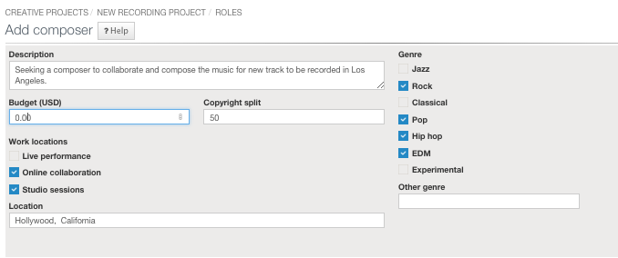

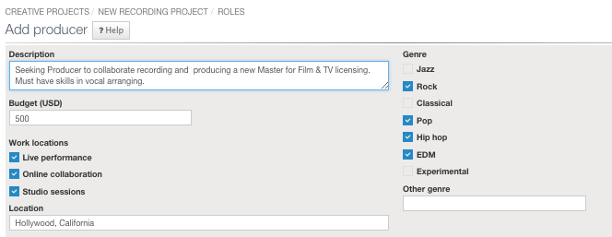

## Real-time Messaging

Students communicate in real-time using the message center. Message notices are also sent by email:

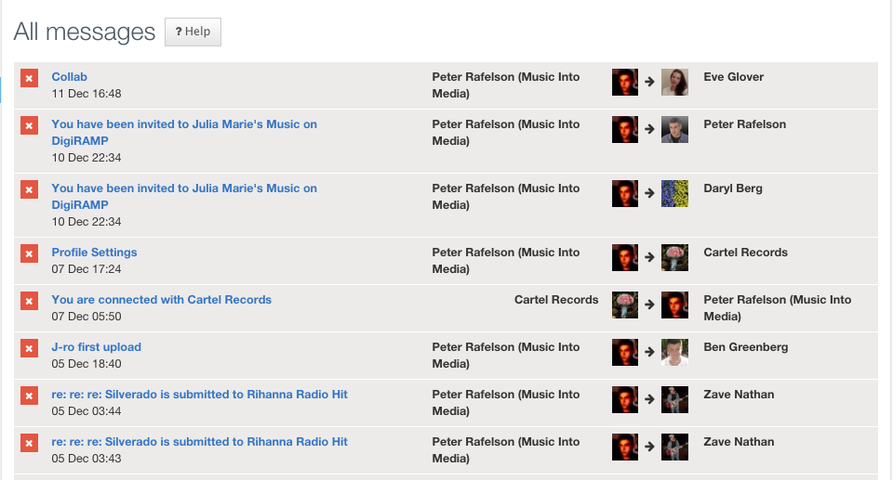

# Students learn legal requirements and industry practices

DigiRAMP walks students through the step-by-step process of registering and organizing the legal and administrative requirements to engage in the business of music. With complete help files and tutorials the process is easy and educational. As users set up their own business, they can now enjoy the benefits of tools, which help empower their creativity and offer the chance to interface with the actual music industry. By managing legal rights and organizing your information, you are then able to collaborate with other artists, promote, market and submit your work to live opportunities from record labels, TV companies and film studios.

## Publishing

The business of Publishing is based on licensing rights and collecting income for numerous parties. Each creator of a composition or work has publishing rights (50% of their stake in a copyright is their publishing share.) By registering song splits, publisher information and assignment agreements (Publishing deals) with co-creators and co-publishers, each student is guided though this crucial part of the music business. DigiRAMP helps educate and assist each creator through the legal process in a simple and streamline publishing module.

## Common work

All creative work starts with an intellectual property (IP). The moment a student creates any music, they own the rights to the underlying IP – this is called a “commonwork.” Students will learn how to register and manage their own copyrights. Each recording uploaded to DigiRAMP automatically creates and keeps track of all commonworks and copyright information. Composers, lyricists, writers, arrangers and stakeholders (including publishers) are each listed in a commonwork. Each stakeholder is notified directly and must confirm their splits and ownership agreements in a legal document, which governs each commonwork.

## Creators

Creators are the individuals who contribute to the copyright or composition of a commonwork:

* Writers
* Composers
* Arranger

Each creator is responsible for managing his or her own legal and publishing information. On shared copyrights, each creator is notified and asked for confirmation when they are mentioned in a copyright of “Common work.” Then, they may also add their publisher information whether they self-published or signed to another publisher. Each student who collaborates will learn what information and registration is required in order to license and monetize music.

## 

## Masters

The act of performing and recording music results in the creation of a Master recording. Each recording also contains rights belonging to the “Contributors.” These include the stakeholders, owners, performers and anyone who works on the fixation of a recording. Even engineers and producers may have rights, which need to be registered in order to properly copyright the phonographic recording.

Even if some services are provided, as “work-for-hire,” there are still credits, which can also be added and managed for each recording. Everyone deserves recognition for their contribution - DigiRAMP ensures that all information is added and proper credits are noted.

## Contributors

Any one who is involved in the fixation of a recording “Master” is a contributor. This can be the role of:

* Musicians
* Producers
* Artists
* Engineers
* Recording studio owners
* Label owners
* Performers

Registering the interests of a Master recording contribution is distinctly different than that of a creator of a commonwork (the song or composition copyright). DigiRAMP helps students learn these definitions and assists in registering and managing each party’s role, ownership structure and income revenue split derived from a master recording.

## Legal documents

Legal information and contracts are central to all business. DigiRAMP provides tools to create these agreements with support for:

* Legal Templates
* Digital signatures
* Agreements
* Warrants
* Interested party information (IPI’s)

Any contract or document can be uploaded or created online and edited to include the proper legal language for each party involved. Legal representation by third parties such as managers or lawyers is also supported.

# THE DigiRAMP Business ECO-SYTEM

Music Industry opportunities offer student the chance to submit their work to real requests posted by actual professionals and companies:

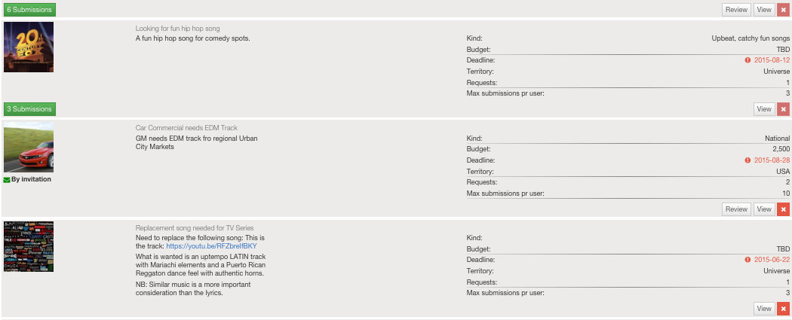

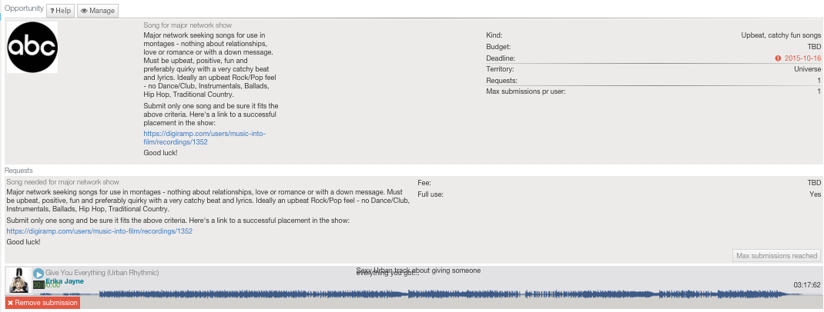

## Learn licensing

Just selling music or making a simple synch license for film or TV can be very complicated. DigiRAMP explains how each entity interacts in a complete eco-system and marketplace:

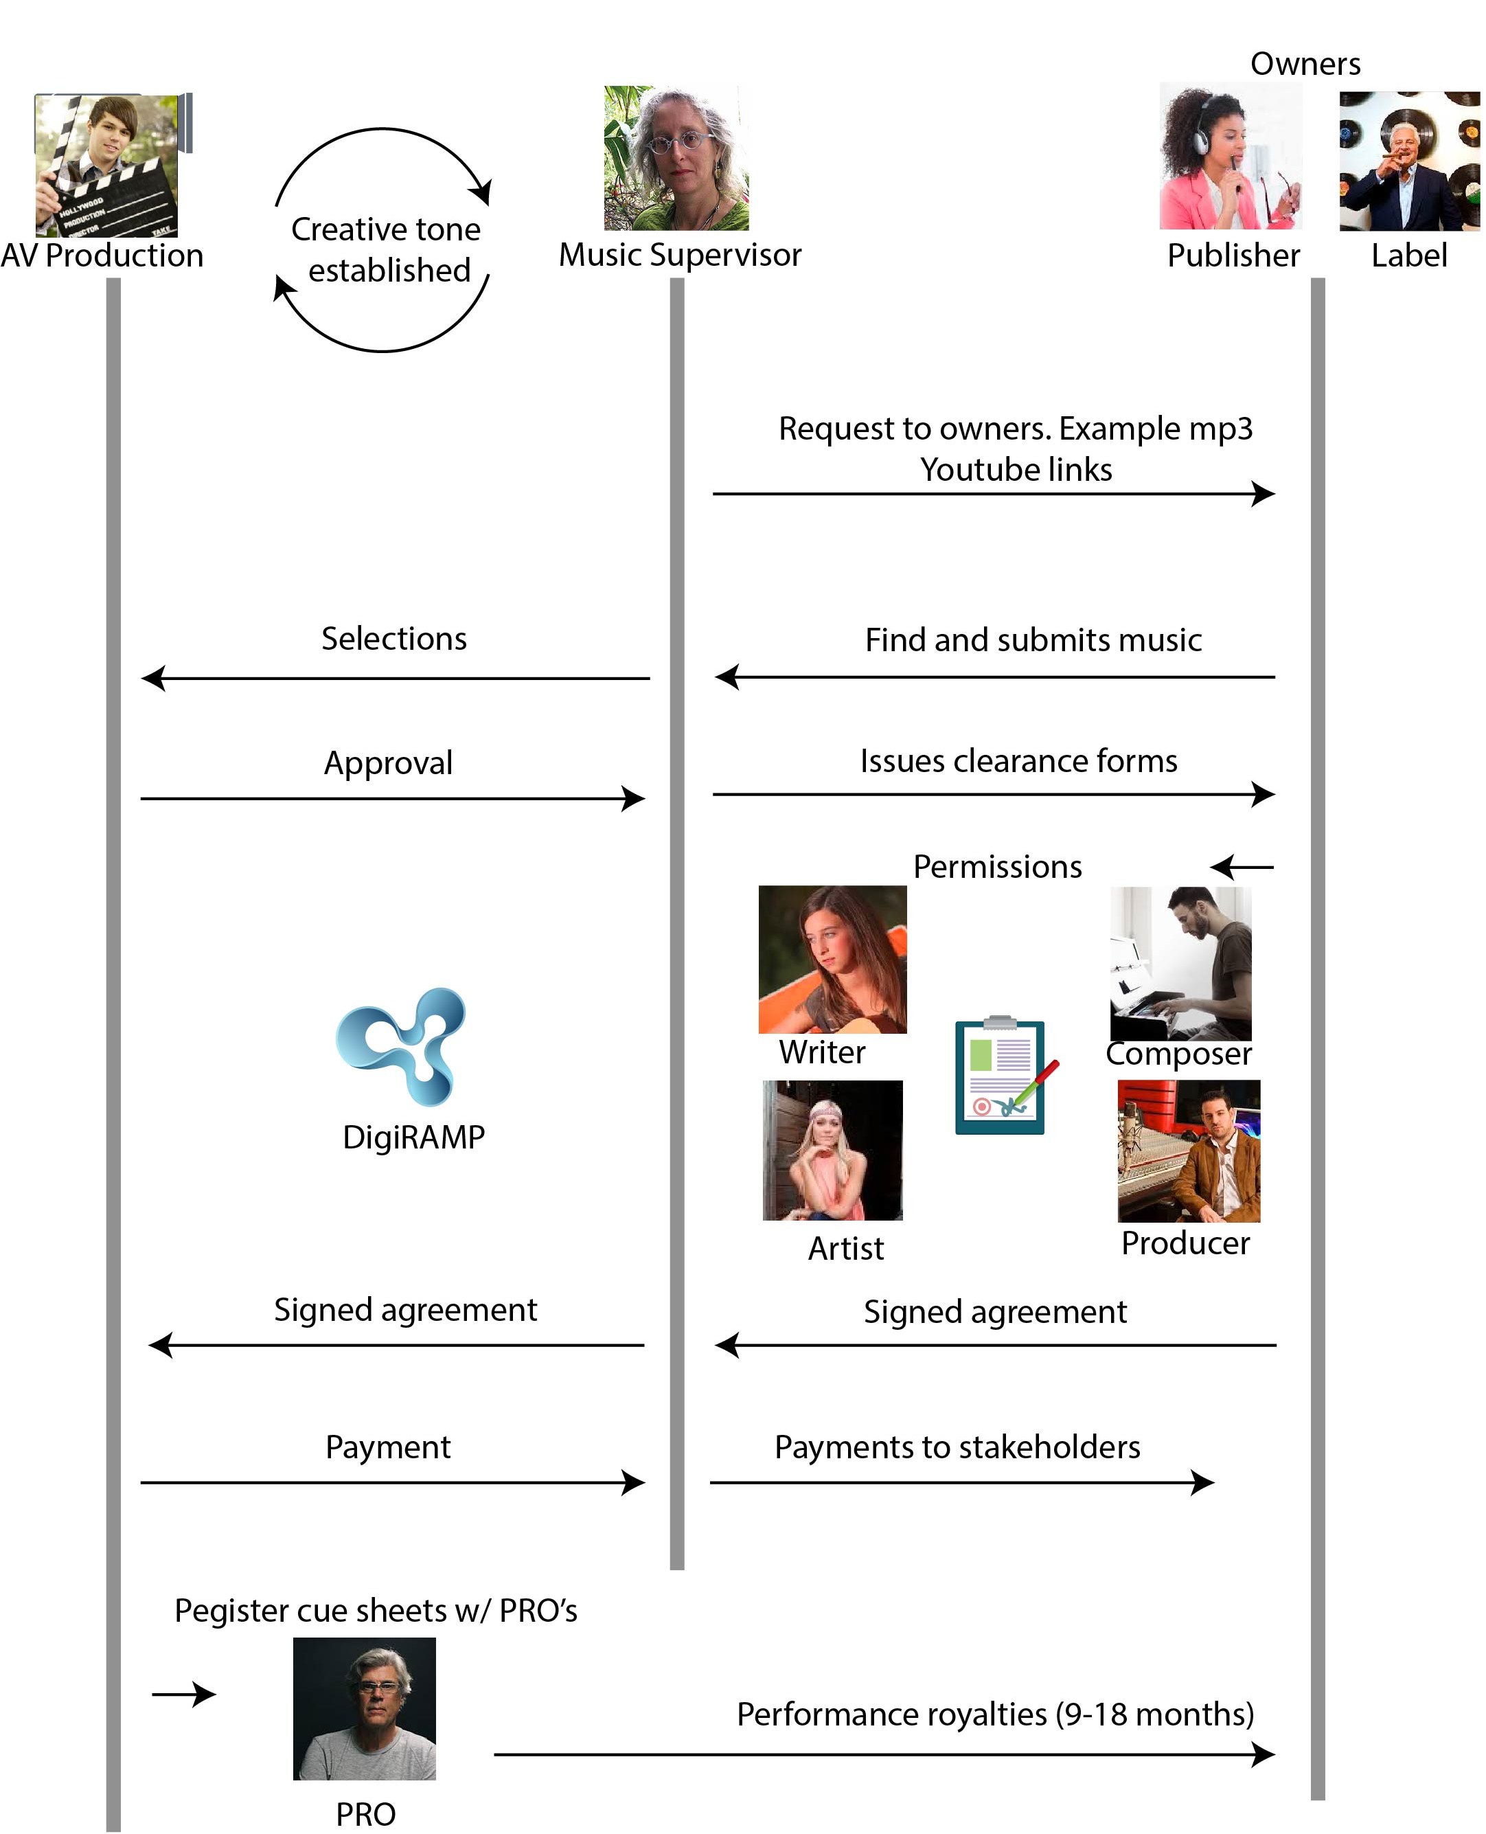

# Rights & Revenue streams explained:

# 

# Manage your own business

## The Dashboard

The DigiRAMP Dashboard is where each student can access and manage all their individual business features, personal, legal and financial information and user settings:

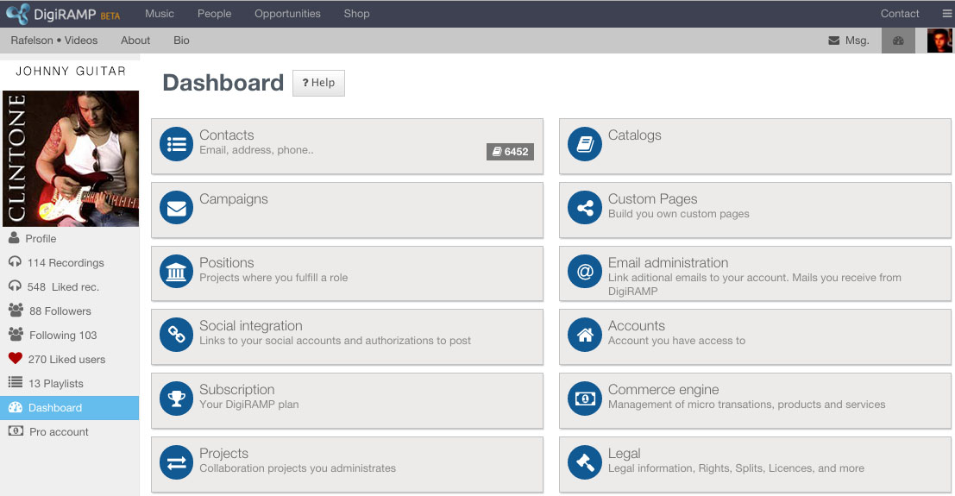

# Dashboard Control Panel Features

**Contacts**- This is a robust CRM (Customer Relation Management) system for importing, storing and managing your DigiRAMP network Contacts & Groups. Groups are created for specifically communicated with and targeting certain types of contacts such as label executives, supervisors, producers or companies with which you wish to engage. The Campaigns feature is ideal for notifying your Groups of any promotion, announcement or news update.

**Catalogs**- Access every catalog on DigiRAMP which you have authorized permission to access. If you are working on catalogs with other users, you may both share access with other users who have specific permission to perform particular tasks such as uploading, adding legal info or managing financial documents. Individual users are authorized with custom permissions to access any section of an account or catalog on DigiRAMP.

**Campaigns** - An email management system for creating group e-mailings for communicating to a large number of your contacts.   Examples could be: announcements, news, new releases, opportunities, upcoming shows, new products for sale, direct ticket sales etc.

**Custom Pages** - Make your own mini website or EPK right on DigiRAMP.  Create a new page, pick or edit a layout and then, add content (including a bio, video, photos, music, blogs, etc.) and advanced features and modules to each Custom page – then make it visible on your DigiRAMP profile navigation bar by clicking "Show in Menu"  - the new page tab will then be seen at the top of your DigiRAMP Profile.

**Positions**– An online collaboration can be easily created with project team members. This feature shows a list of your own positions and roles in any "Project" in which you participate.  A project is how users can request, post or join in on a collaboration and work together online.

**Emails** - Add and link additional emails to your account - this may be particularly useful if other users send you notifications regarding your legal or publishing rights or requests.  People may not always know the main email you are using in your "Profile."  By adding additional emails to your account, you can receive notices regardless of which email others send to.

**Social Integration** - Add and edit links to your other websites and social networks.  This will appear on your profile and all "Custom Pages" which contain your "Social Links."  *Note that you still need to turn on "Authorization" in order to post and share from DigiRAMP to your other networks*- by linking your DigiRAMP account with your favorite social accounts you can authorize, login and post directly from DigiRAMP - *one central site for quickly promoting, sharing and posting all your work saves time and hassle!*

**Accounts**- Access every account on DigiRAMP to which you have authorized user permission(s) to access. Each *account owner or administrator has the choice to allow who may access some or all of their account features.*

**Subscription**- View and edit or upgrade your current DigiRAMP plan.  Here you may sign up or upgrade to become a "Pro" user and have your own "Pro" account with many additional business and management features.

**Commerce engine -**This is where all the features pertaining to legal agreements, income and revenue are located.  Register your own Publishing company, Label, and your own retail Shop  - Administrate your products and services. Set up and control where all payments and monies are sent and who shares in the revenue from any purchase. All payments are made in real time to each stakeholder who participates in any one revenue stream. Legal agreements can be created from templates and signed digitally which then can govern the income streams and rights to any work or product on DigiRAMP.

**Emails (preferences)** - Select and turn on/off Emails you wish to receive from DigiRAMP.  Select your choices of options for general or specific notifications of Opportunities, News, new features and more…

# Manage a larger company

In addition to an individual user accounts, DigiRAMP supports Business accounts for much larger businesses and companies, which may have numerous employees and users. In a Business Account, an entire staff or corporate business can administrate and authorize its employees to access and use one single account.

## Catalogs

A Business account supports numerous roles and catalogs, each with registered users, copyrights, recordings legal and financial documents– this is ideal when one company administrates, manages or represents many other rights holders. Students learn how labels, publishers, management firms and legal firms use this Pro feature for all their employees, artists, clients, partners and signed individuals to whom they account and service.

## Users

A company Business account can also invite its users to access the entire account or only specific features with authorized permissions for access to each area. Whether a company has interns or C-suite executives, each user can be managed and provided with secure access to only the appropriate sections.

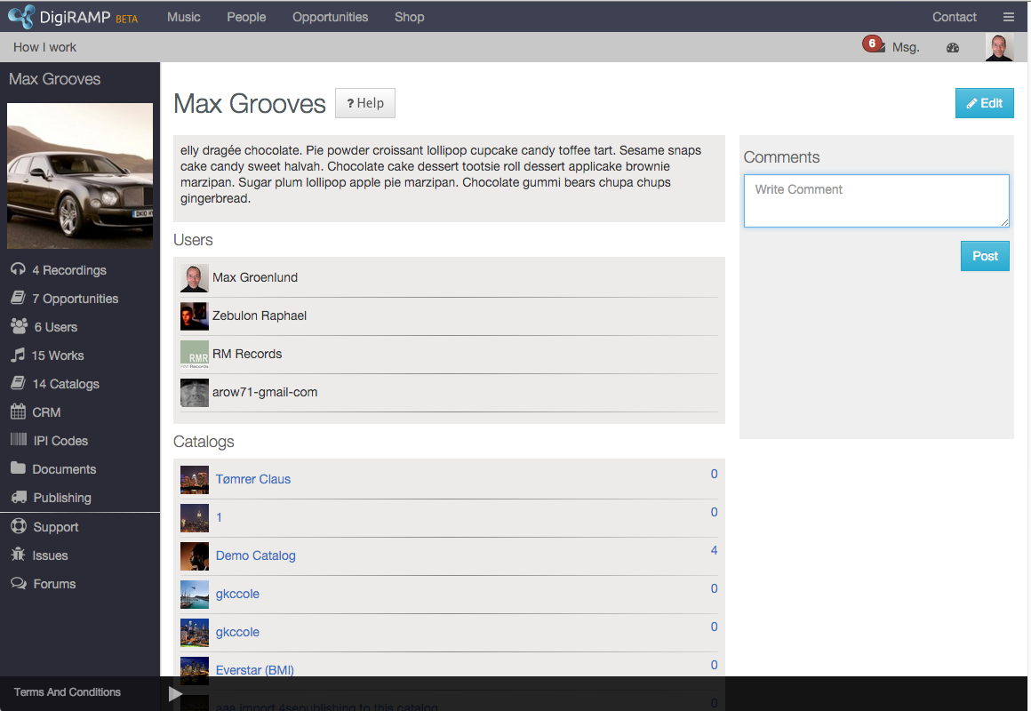

# Pricing

## 20-100 Student Licenses

## 100-250 Student Licenses

## 250-1000 Student Licenses

## 1000+ Student Licenses

## DigiRAMP Pilot Program

DigiRAMP is confident in its value and product. We can negotiate pilot programs and the customization of additional educational features supporting specific academic needs for limited periods of time.

## DigiRAMP Seminars

DigiRAMP welcomes the opportunity to present ongoing live appearances and educational on-campus events for the student body. We will always value the interaction and process of engaging directly with students and users.